**REQUIREMENTS FOR MONAY WALLET**

1. At the time of registration - add a new tile for "secondary user" (family / servants / etc).

Current Monay app supports two types of User Registration i.e., **“User”** and **“Merchant”**. Once a user chooses “**user”** Now App should allow him/her to choose as a secondary user for an existing account or **he/she can continue as primary user**. This process exists as of now in current Monay wallet.

Primary user registration process is same as current user.

In case Secondary User is chosen, below options need to be provided once the secondary user has verified his/her number:

Option 1: text box to enter primary user id The primary user ID is be the phone number of the Primary User

Option 2: The Secondary user can Scan a QR code from the Primary User to get linked (which means we need to add a QR code to Primary Users settings page)

Option 3: The Primary User sends a text invite to the secondary user join his/her account, if the TEXT is provided, the user needs to register and will automatically registered as the secondary user after verification of Secondary Users mobile number.

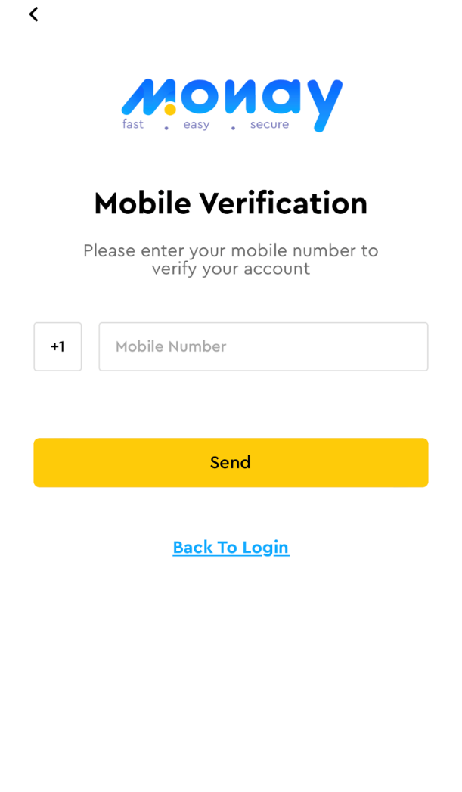

1. All the transactions made from secondary user will be visible from primary user’s wallet.
2. Take care of all the issues with payment transactions

In case of USD (US dollars) integrate with Payment Engine APIs (which are already working).

In case of INR, need to build new APIs like UPI consumption, Internet Banking, Credit Cards.

On Ramp and Off Ramp transactions need to be built.

Trouble Shooting:

1. Payments are not working,
2. KYC (Know Your Customer) should be designed country specific based on the country laws. In this case for now we are trying to launch in India, hence India KYC should request Aadhar & PAN card details etc. In case if we store these key details, then Data Privacy?

Further issues are mentioned below:

**Issue 1:** Unable to add money using new card, got the below error

Note: Card details have been added to ‘Saved Cards’ section.

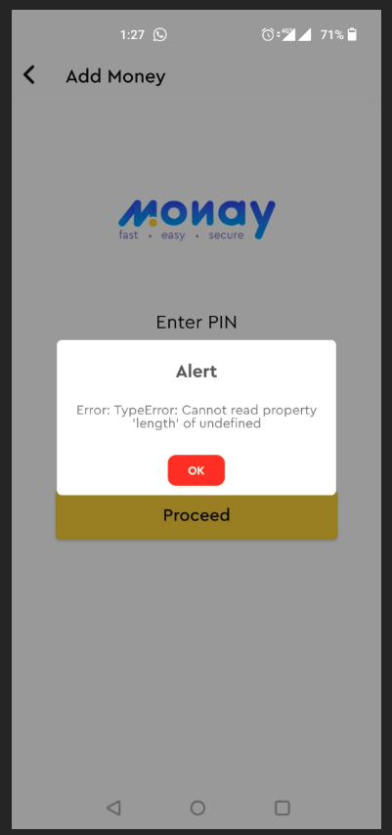

**Issue 2:** Unable to add money using saved card, , got the below error

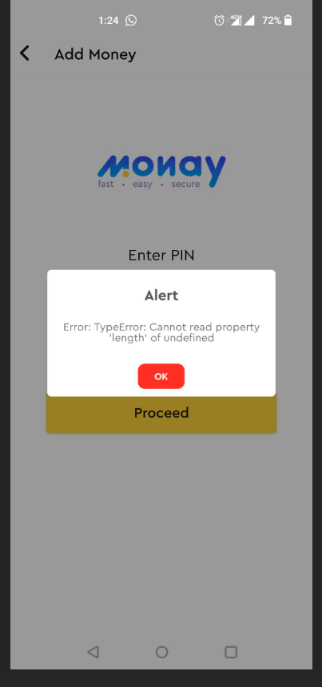

**Issue 3:** Unable to send money using saved card

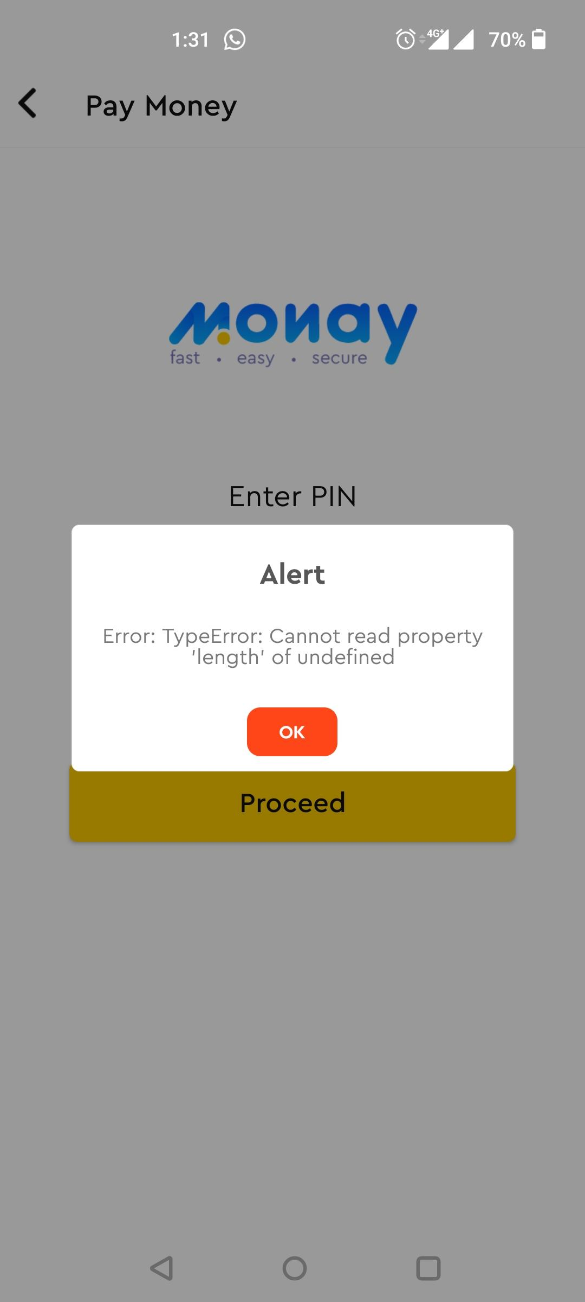

**Issue 4:** Unable to send money using wallet

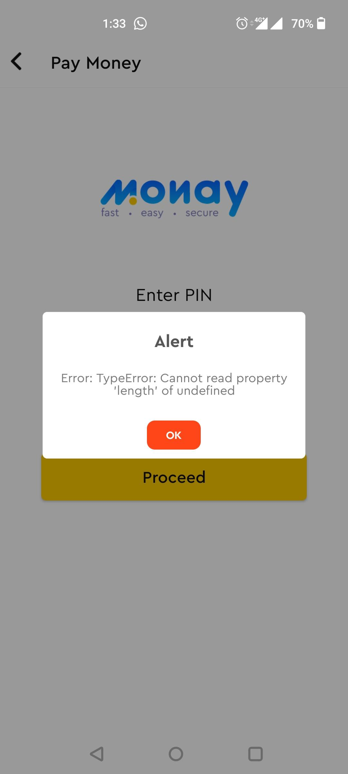

**Issue 5:** Unable to send requested money by another user

**Issue 6:** Verification code is not received (to existing email) to change the email

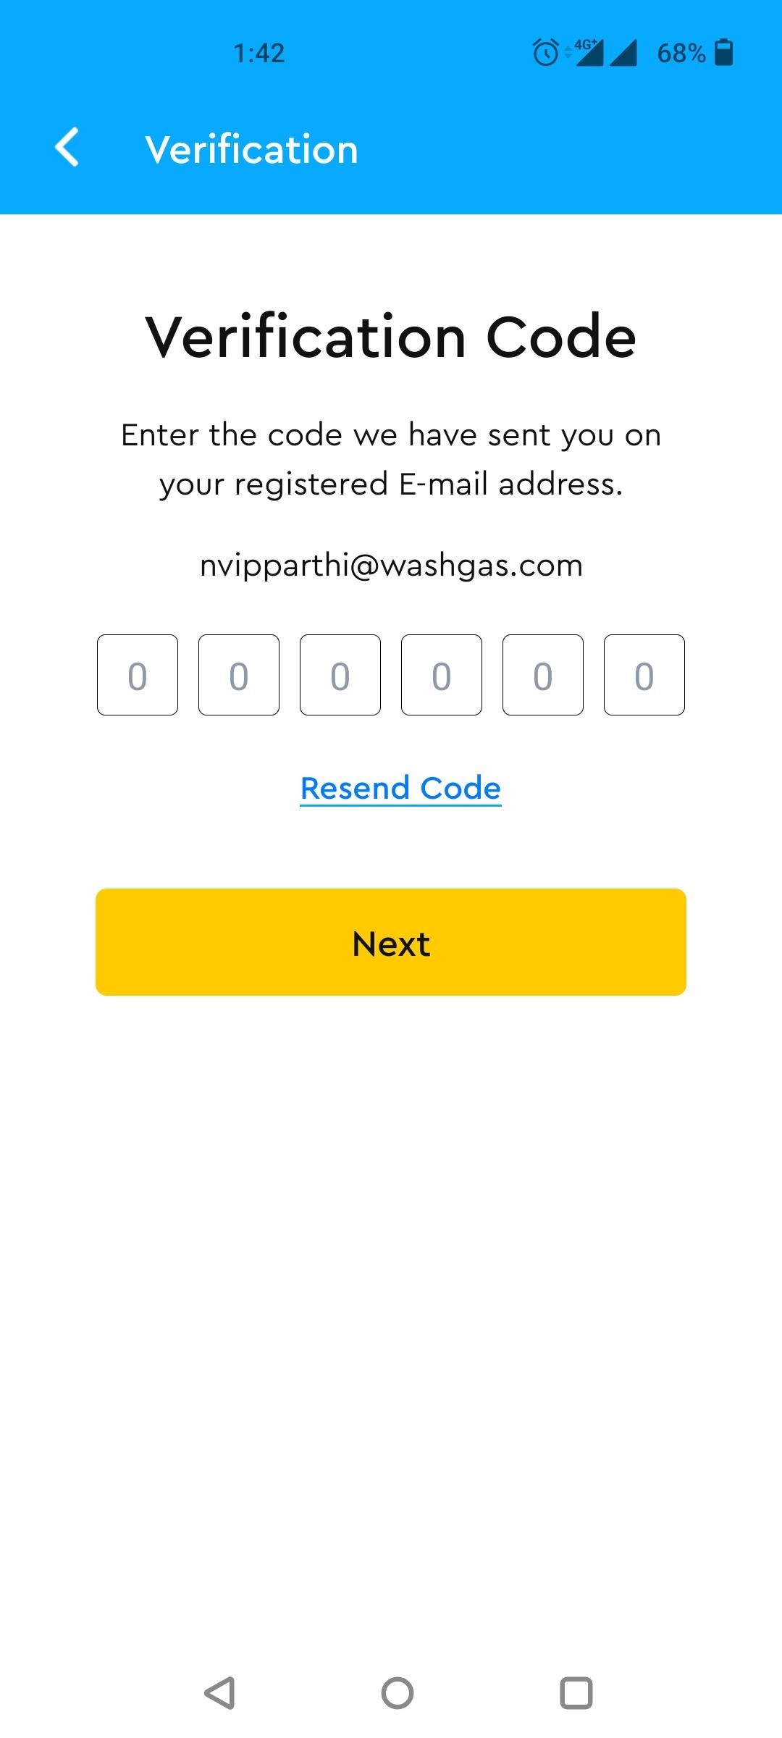

**Issue 7:** Unable to withdraw money

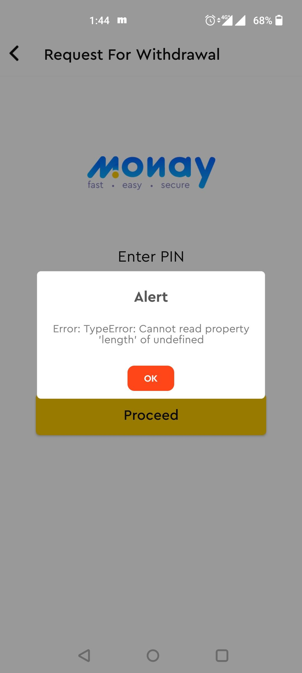

**Issue 8:** Unable to delete existing bank account.



**Issue 9:** Unable to add new bank details

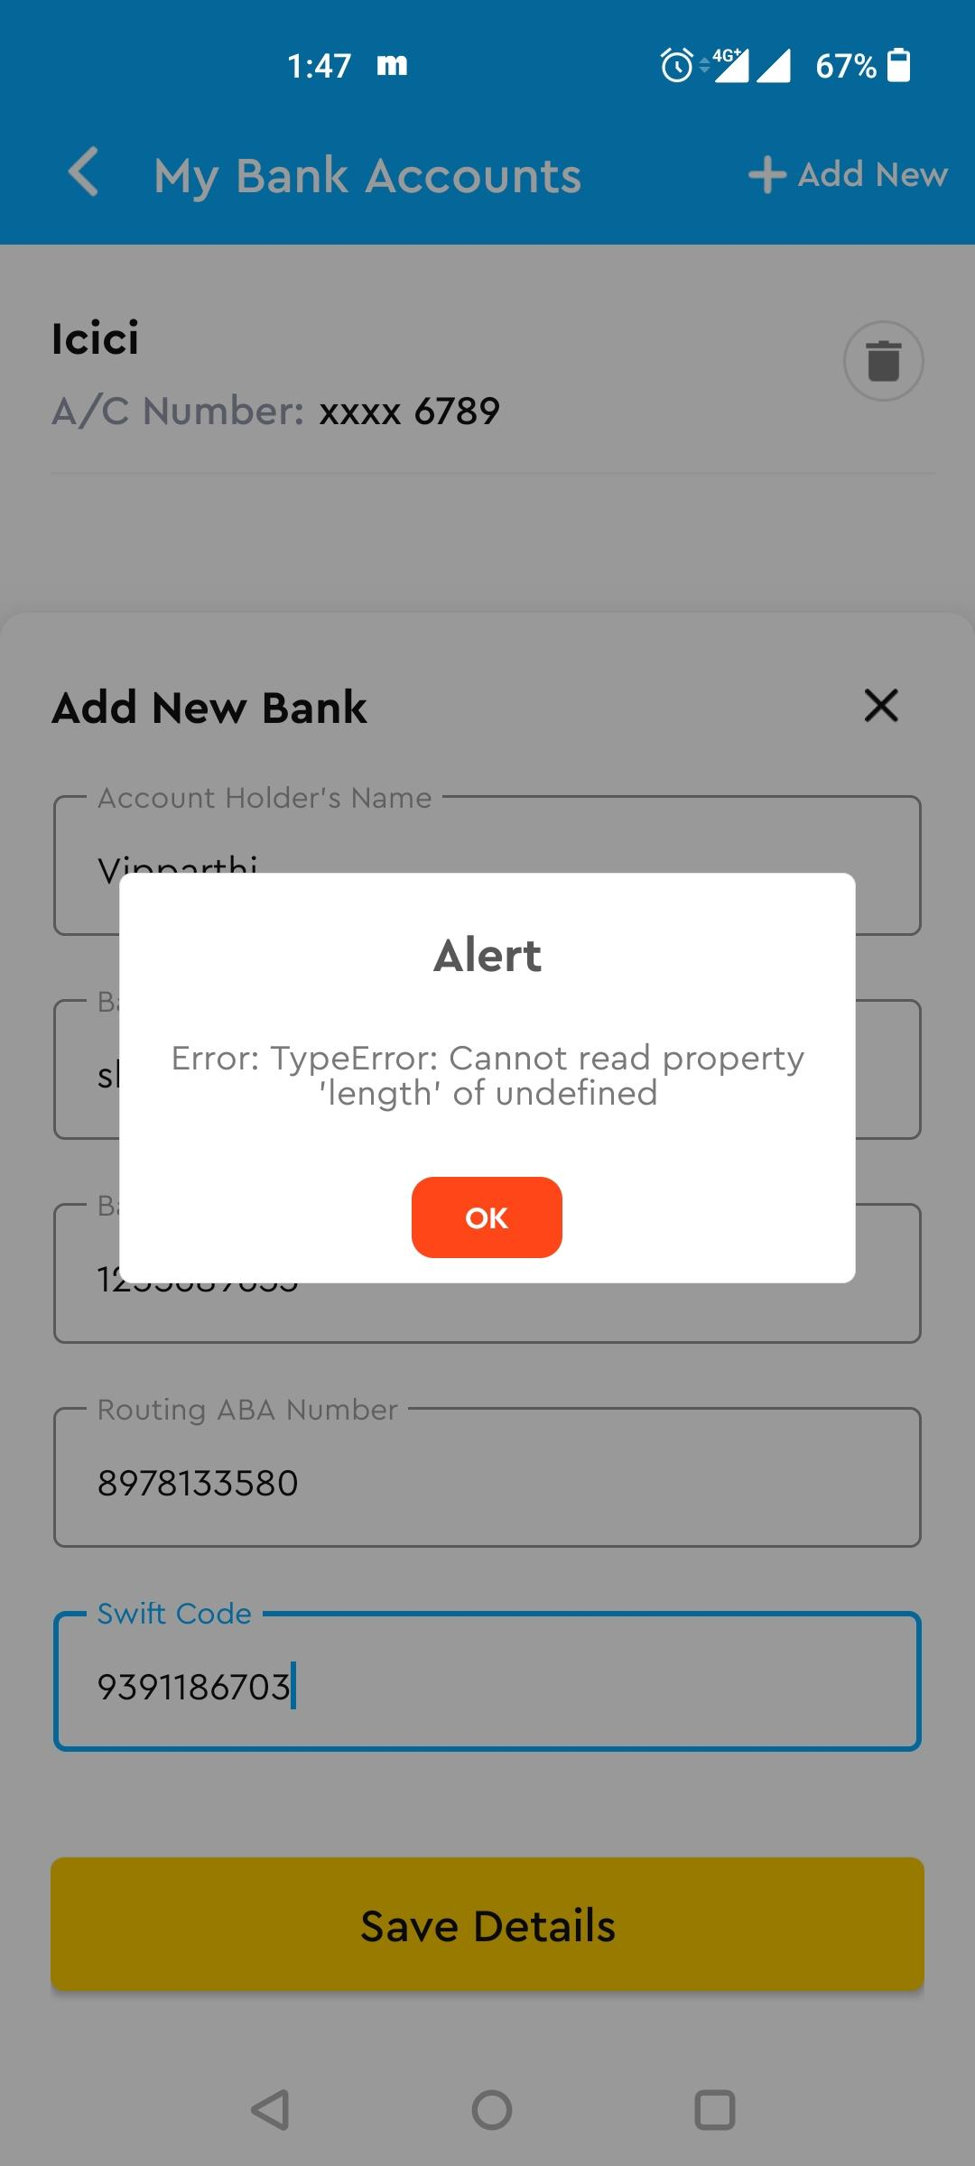

1. Get the India MONAY WALLET APP up and running – Allow the app to support all regions? I.e., “user” must be able to select country code and corresponding currencies in all pages wherever applicable.

Here are the few scenarios:

**Consumer:**

**Scenario 1:**

* Parents download the app
* Link the Bank Account to the wallet
* Generate Code for their kids’ wallets and share with kids to activate their account and link
* Parents send the money to kids’ wallet
* Kids scan QR code to make payments

**Scenario 2:**

* Kids download the app
* Generate Code for parent, send via SMS, email, WhatsApp
* Parent Download the App
* Link the Bank Account to the wallet
* Links with Kids Wallet Account
* Parents send the money to kids’ wallet
* Kids scan QR code to make payments

**Scenario 3:**

* Parents download the app
* Link the Bank Account to the wallet
* Generate Code for their kids’ wallets and share with kids to activate their account and link
* All Kids account are inter-linked
* Kids can transfer money between themselves
* Kids accounts are passcode protected

**Associated Reqs:**

* Parent shall be able to place auto-top-up
* Parent can restrict with max-top-up amount
* Family (Parent, Mother, Kid(s)) Wallets shall be identified and interlinked
* Parent shall be able to reconcile on the spend / transactions

**Merchant:**

* Merchants shall be registered and onboarded
* Placed a QR Code at the shop/store to scan and we shall also allow through standard UPI QR Code such as “Bharath Pay”
* Merchant shall be able to get details of the kids scanning/users scanning to make payment
* Merchant instance shall be powered with nudge (from our Nudge CPaaS) communication
* Merchant shall be able to plan promotions and send communication to their frequently visited consumers

**Features**

**1. Auto top-up**

* User will agree to auto-top-up terms and conditions
* Monay wallet will recharge the wallet if it goes below a specific amount
* The amount on which auto top-up will occur shall be decided by the user
* Only primary users can use an auto top-up feature
* Bank details will be saved
* Users don’t need to take any action
* No 2FA will be required on auto top up
* Only cards that won't ask CVV on recharge will be applicable
* ACH option in auto-top-up will be provided

**2. Minimum wallet balance & refill amount.**

* After a minimum amount user will be notified to recharge the balance in the Monay wallet

**3. Limit multiple secondary accounts**

* The primary user can restrict the amount for the secondary user

**4. Enable/Disable secondary user by primary user**

* The secondary user will be by default disabled, primary user will enable to activate the secondary account

**5. Primary user as a secondary user of another primary user.**

* At a time, the user can either be a primary or a secondary user**.**
* The secondary user can choose a relation with the primary user
* Maintain a relationship between primary and secondary accounts.
* While the secondary user is registering secondary user will be allowed to use the primary user and relation (dropdown) with the secondary user.
* The same phone number and email can be associated with multiple accounts: primary and secondary
* The user will be identified by phone number and a flag: primary or a secondary use

**6. QR code to be used for referrals.**

* QR code will be for registration and payment

**7. Biometric Information**

* Users can login to the Monay wallet application with their fingerprint and Face ID.

**8. Buying Products**

* Users can avail features such as buying groceries and clothing to purchasing insurance and stocks.

**9. Ready Cash**

* Monay provides small terms and instant digital loans to the users
* Certain limits of the loan will be decided according to the cash flow of the user using Monay wallet.
* Users can avail ReadyCash service for a duration of four weeks; with the option to pay back early as well.
* A user can get only a single loan at a time of up to INR 10,000.
* The eligibility criteria of Ready Cash is that the user should have a cashflow history of 10,000 INR.

**10.** **Stock and crypto trading.**

* Users can trade stocks and cryptocurrency using the Monay wallet

**11. Payment on third-party applications**

* Monay wallet API should allow payments on third-party applications like food delivery, taxi-hailing, restaurant, hotel booking, and gaming.

**12. Charity donation feature**

* Monay wallet can be integrated with reliable charity organizations in the country, where users can donate

**13. A bill management tool**

* Monay wallet can help users track, review, and pay their bills

**14. Gift card and reward offerings**

* Monay wallet allows users to create a gift card for the users. A promo code will be generated by the system which can be used on the e-commerce website.
* On availing of Monay wallet features, users will be offered loyalty rewards

**15. In-store QR Payments**

* In-store QR Payments can be made using the Monay wallet

**16. AI-powered financial assistants**

* Monay wallet help users make smart, customized decisions about their money.
* Budgeting feature using AI can give analysis or insight according to customers' data
* Smart financial assistants such as smart advisor who continuously reviews clients’ subscriptions and bills, manages their budgets, proposes saving and investing strategies, and provides other relevant feedback on how to reach financial goals.
* Smart assistants can notify users of discounts at their most frequented stores while shielding them from incessant marketing, creating custom budgets, or seeking out the best loan rates and insurance options based on a specific user’s needs.
* Remind users to pay their bills
* AI-based chatbot, provides message-based personalized advice to users, and answering questions on whether they can afford something

**17. Implement Adhar pay (For India)**

* Adhar Pay is the most common digital platform used in India. Even small consumers particularly farmers are using it frequently due to its ease of use. Integrate Adhar Pay with Money wallet to increase the reach of the wallet services.

**18. KYC Verification (For India)**

* To make the registration process user. KYC process should have minimum fields. Verification of the KYC process can be by Adhar's number.
  + Adhar number
  + Real time picture capture
  + Pan card number
  + Bank Account number